**St Andrews Parish Church Broughton**

**PCC annual reports 2024**

**Key people and their roles within the church during 2024:**

* Rector: Nicki Hobbs
* Assistant Curate: Huw Yardley
* Church Administrator: Laura Connolly
* PCC Members: Charlotte Bodicoat, Amanda Doyle, Jan Manning, Gill Nottingham, Becky Rose, Natalie Vowden, Geraldine Woodley, Sarah Wyeth
* Church Warden: Peter Horrix
* PCC Secretary: Becky Rose
* Deanery Synod reps: Peter Horrix and Anne Toms
* Sunday School Leader: Charlotte Bodicoat and Natalie Vowden
* Safeguarding Officer: Anna Phippen

**Reports included in the following order:**

* PCC Report (Prayer and Worship/Discipline/Outreach/PCC Business/The Future/Safeguarding
* Updated Electoral Roll
* Churchwardens Fabric. Quinquennial & Reordering Report
* Treasurer’s Financial Statement/Report/Independent Examiner’s Statement
* Deanery Synod Report
* Sunday School Report

**2024 PCC Report**

**New Ministry**

We were delighted to welcome Revd Huw Yardley to the benefice as Assistant Curate following his ordination as deacon in July. He is here to train for about three years, and has already been an asset to the churches and communities here.

**Prayer and Worship**

Throughout 2024, Broughton Church has a service at 9.30am every Sunday (except for benefice services on 5th Sundays). These are a mixture of Communion, all-age worship and morning worship. The Sunday School continues to meet twice a month during termtime. Numbers attending the services and Sunday School have again continued to grow over the year. Weekly Morning Prayer and Midweek Communion services continued, with steady numbers at Morning Prayer, and a slight increase in numbers at Communion. Weekly Benefice Night Prayer on Zoom has continued to be attended by a regular core group, with a few others joining when they are available.

Our online service for anyone worshipping at home or at a different time was produced at various points, including Advent and Christmas. Views of this vary between 3 and 50 for each recording. Other resources to facilitate prayer and worship at home were produced throughout the year and sent by post to those without internet access.

The church building is open during the day for anyone who wishes to pray or reflect in the quiet. Our prayer board is well used, with visitors and congregation members alike leaving prayer requests which are offered during Morning Prayer each week.

**Discipleship**

During Lent, a group met from across the benefice, working through material called *Hymns We Love*. Each session looked at the story behind a different well-known hymn and explored how it might be relevant to us today. During Advent, we continued the musical theme, completing the final *Hymns We Love* session on Hark the Herald Angels Sing, and then looking at the group’s favourite carols, using reflections from Embrace the Middle East.

There were extra services at various points, marking significant occasions in the church year. These included communion and ashing on Ash Wednesday, Maundy Thursday shared meal and communion, Good Friday Walk of Witness with Cransley and Mawsley Churches and Broughton Baptist Chapel, Harvest Festival, Remembrance, and a variety of Christmas services.

**Outreach**

Occasional offices continued to be an important part of our ministry and service to the wider community. Broughton Church saw six baptisms in 2024, with most taking place during Sunday morning services. We took five funeral services, with two being in the church building, and the rest at the local crematorium.

Other outreach in 2024 included a mixture of services and community events. Lanterns for Loved Ones and the Baby Loss service offered support to those who are grieving the loss of a loved one. The village uniformed organisations took part in our Remembrance Sunday service, and Pizza Praise made a special return for Easter and Christmas.

Our churchyard was used for an Easter story trail, which proved very popular with younger members of the community. Following its popularity the previous year, we hosted another Christmas craft and gift market in the church grounds. Stormy weather meant we had to cancel the planned light show projected onto the tower by a village resident. However, this went ahead to coincide with our carol service instead.

We were pleased to be able to welcome the village pre-school and primary school reception year to the church to hear the Easter and Christmas stories. The whole of Broughton Primary School visited the church once again for their Easter and Christmas services, and the school choir sang beautifully at our carol service. Year Six also played a significant role in the Village Act of Remembrance on Armistice Day, which is led by the church with support from the Chapel. We also regularly go into the school to lead assemblies and help with RE provision.

**PCC Business**

The PCC held 11 meetings during 2024, discussing and developing the church’s mission, ministry, fabric and business. Work on the reordering project continued, with members of the Diocesan Advisory Committee, the Archdeacon of Oakham and the Church Buildings Council coming for a site visit to see the plans in situ.

**The Future**

As we look ahead there are certainly challenges facing the church in terms of financial and practical resources, but we have the opportunity to build on successes of 2024 – worshipping together, sharing the good news of God’s love and meeting the increasing needs of those around us. To do this, we need to be willing to use the gifts, passions and resources that God has given us to serve him, one another and our community. I encourage each of us to ask God how we can be involved.

My thanks to the church warden, PCC, volunteers and all who have supported the work of St Andrew’s over the past year. There is much to thank God for. As we look ahead, let’s commit ourselves to prayer and following Jesus.

Revd Nicki Hobbs

Rector

March 2025

**Safeguarding Statement**

The PCCs of the benefice of St Andrew, Broughton with Cransley and Mawsley adopt the Peterborough Diocesan Safer Church Policy and Procedures each year. The policies and procedures are followed by the PCC and those working in any capacity with children or vulnerable adults. Safeguarding information is on display in the church at all times and a copy of the policy and procedures are also available. The Benefice Safeguarding Officer is Anna Phippen.

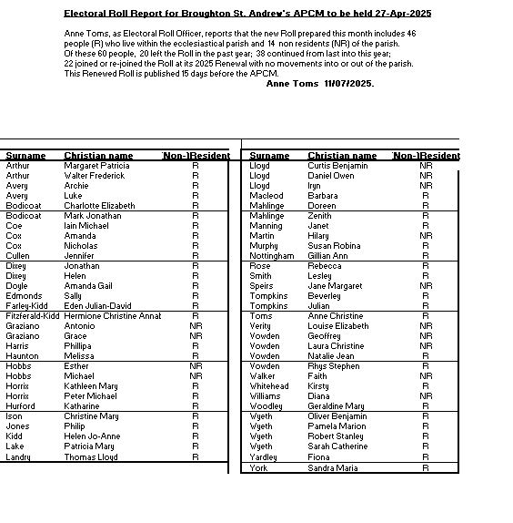

**APCM 2024 – CW FABRIC REPORT AS AT 28TH MARCH 2025**

SUMMARY

1. The church building is structurally sound and weatherproof.
2. QUINQUENNIAL WORKS (REF QIR 2023)
   1. “Priority 1” repairs (mostly roof repairs) have been completed (March 2025)
   2. “Priority 2” repairs requiring cutting back of overgrown vegetation and the removal of moss from stonework have been completed.
   3. “Priority 3” works need planning over the next 5 years. Stone repairs to the church tower are recommended but mostly to reduce long term deterioration.
   4. “Priority 4” items will be good to do but not essential. Some could be incorporated in the reordering works.
3. The interior furniture is functional for static worship but has limited flexibility for other forms of worship or other activities. There is evidence of wood rot where the side panels of pews meet the wall, in joists supporting the pew platforms, and in the platforms themselves. The old pipe organ no longer functions properly, and the wooden floor underneath is rotting. Much of the plaster on the walls is ‘blown’ or otherwise cracked/damaged. The LPHW heating system, whilst still functioning, utilises cast iron pipework that presents continual H&S hazards and is expensive to repair. The gas boiler does not comply with the CofE stated aim of Net Zero by 2030. All of these issues are addressed within the pending Reordering project.
4. The Terrier and Inventory have been checked. Updates are:

* The AV equipment stolen from the Gallery has been replaced
* All other items/records are present and correct.
* Both the Terrier and Inventory Checklist documents are available for viewing in the vestry on request

4) The building and contents are fully insured and the lead/copper metal roof cladding is protected by CCTV.

RESUME OF CHURCH RE-ORDERING PROJECT

We have already completed some of the works needed:

* AV system
* Upgraded mains power supply
* Heating/lighting chandeliers
* Partial re-decoration
* Partial repair/replacement of windows
* Temporary installation of new organ
* Digital Bells
* Sunday School furniture

The reordering design work is complete and has been signed off by the Peterborough DAC. A Faculty application will be made to the Diocesan Chancellor in 2025. The Victorian Society continue to oppose the reordering, however the Church Buildings Council now support the proposals following a site visit and the PCC’s compromise to install an Air Source Heat Pump(s), thus enabling the Net Zero requirement to be achieved.

On the funding front we have worked with fundraising specialists Chell Perkins to prepare applications to a range of funders in the hope we can obtain grants amounting to circa £160,000. However, we cannot complete these applications until we have the Faculty.

There appears little likelihood of any building works commencing in 2025 so we should look forward to 2026 with renewed optimism although costs continue to escalate for various reasons.

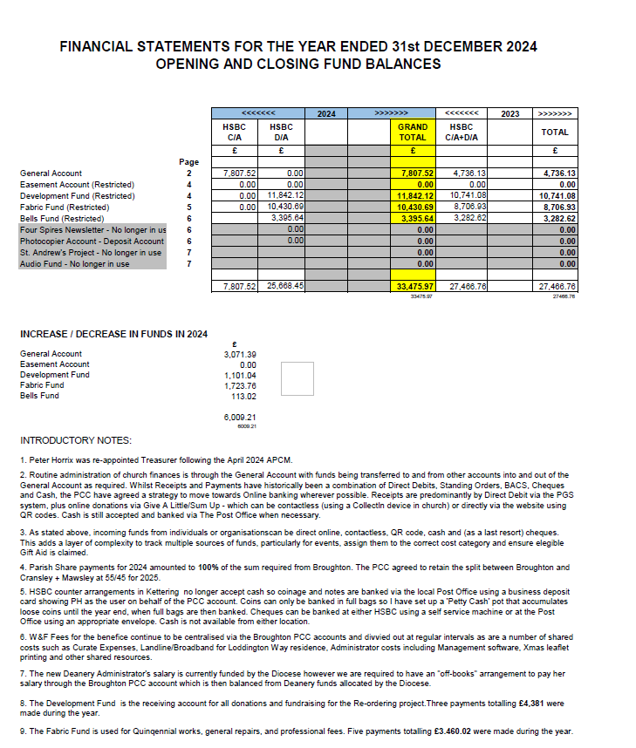

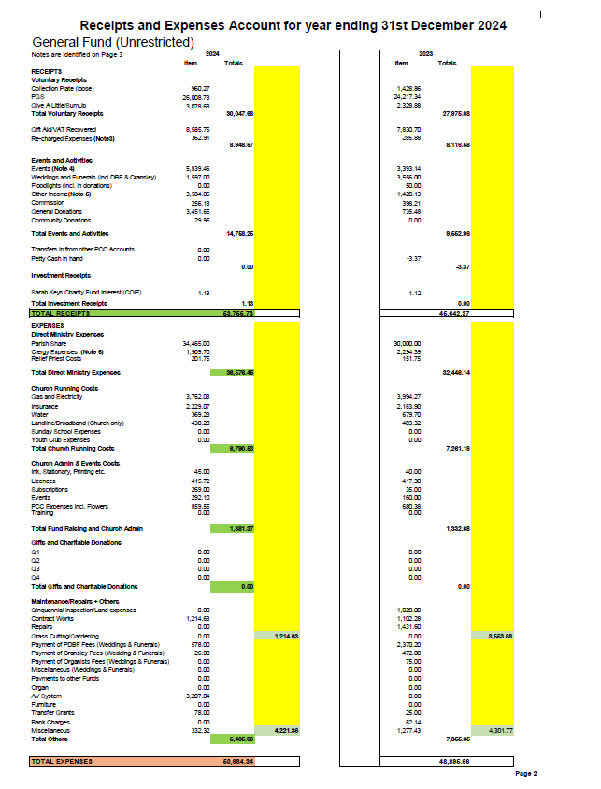

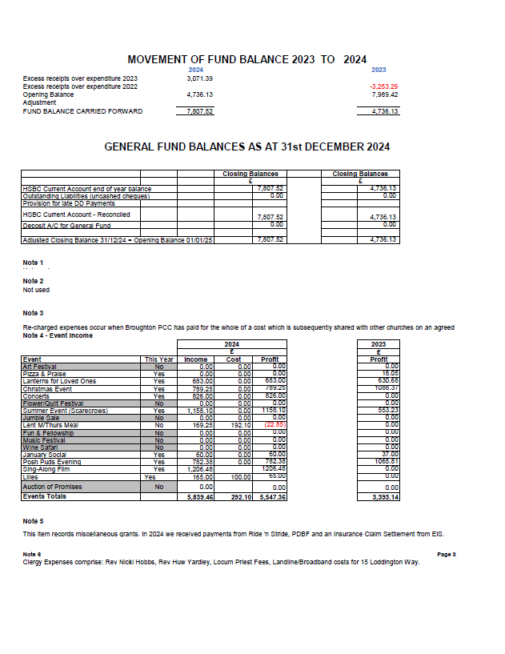

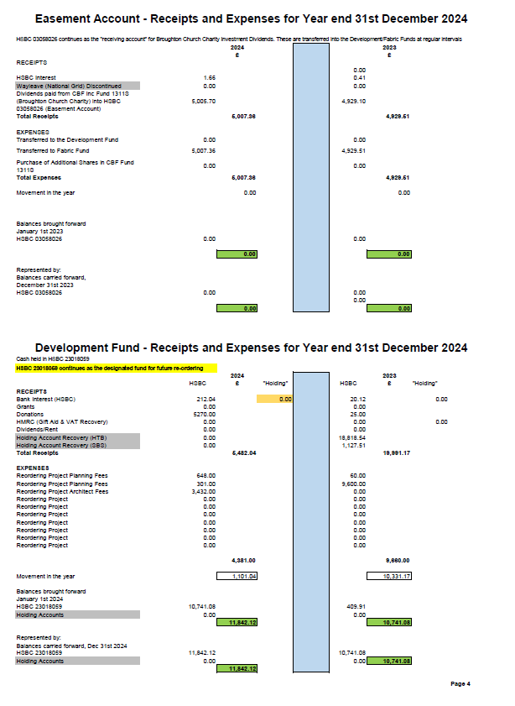

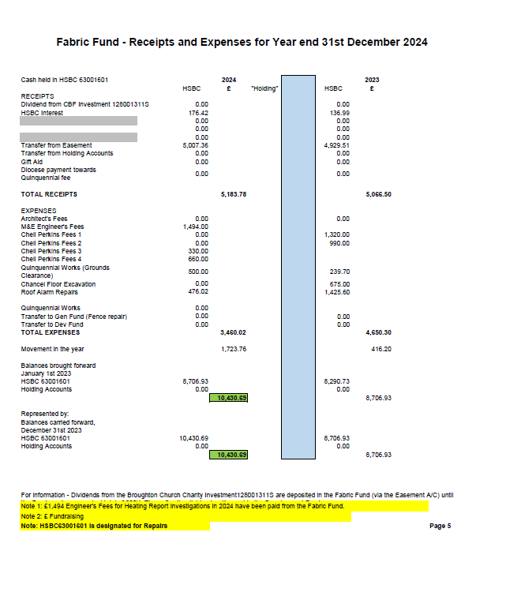

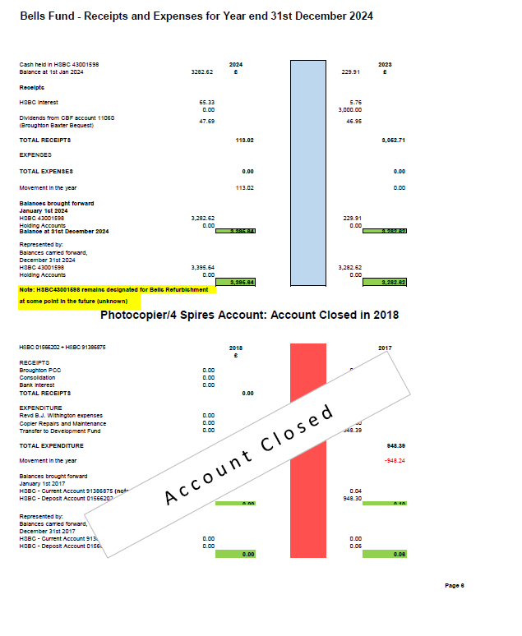

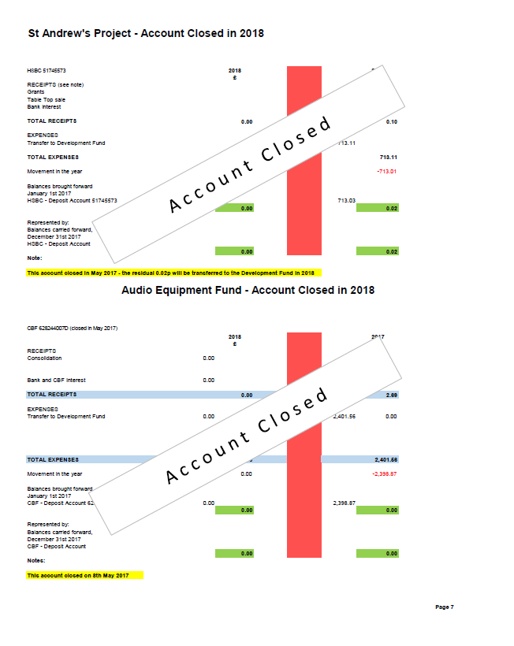

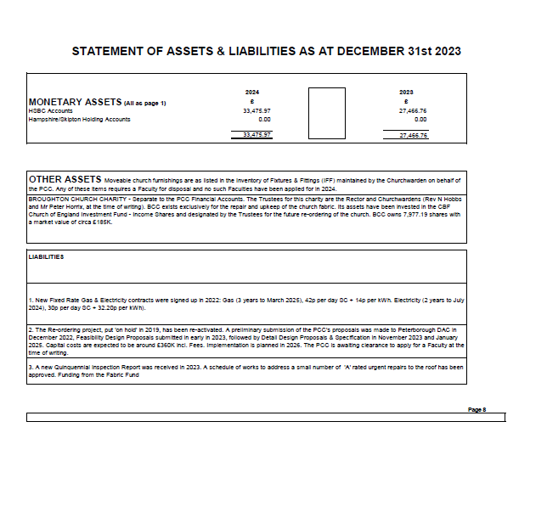

ST ANDREW’S

PARISH CHURCH

BROUGHTON

TREASURER’S REPORT

FOR YEAR ENDING 31ST DECEMBER 2024

TREASURER’S REPORT FOR THE YEAR ENDED

DECEMBER 31ST 2024

This report offers a balanced commentary on the Financial Statement for 2024 and looks ahead to the prospects for 2025. NB References to page numbers relate to the 2024 Financial Statement unless otherwise stated.

**INTRODUCTORY COMMENTS**

There are FOUR active PCC Accounts in HSBC:

1. HSBC Current Account – PCC General Fund (Operational Costs)
2. HSBC Deposit Account – PCC Fabric Fund (designated for Quinquennial and General Repairs, and Miscellaneous Fees)
3. HSBC Deposit Account – PCC Development Fund (designated for a future Re-ordering Project)
4. HSBC Deposit Account – PCC Bells Fund (designated for Bells Refurbishment)

NB The HSBC Easement Account continues in the background as a handling account for dividends associated with the Broughton Church Charity (BCC) (see page 4). These are re-distributed to either the Fabric Fund or the Development Fund so the end of year Easement balance should be Zero.

All payments are made via the PCC General Fund which acts as a “Mother Account” whereby funds pass in and out from the other accounts as required.

Receipts are generally paid into the Mother Account, unless directly credited to one of the first three HSBC Deposit Accounts listed above. Cash/cheques are paid into the current account via the local Post Office using a Business Deposit Card,

Signatories for PCC Online Banking are Peter Horrix (primary user), Jan Manning, and Sarah Wyeth.

The PCC’s main source of income is ‘Personal Giving’ through the PGS Scheme.

The main type of expenditure is the Parish Share paid to Peterborough Diocese.

.

The introduction and promotion of ‘Digital Giving’ has been successful and is moving us on from ‘looking for coins in our pockets’ to a realistic level of donation using debit/credit cards/phones, as many people do not carry cash around anymore. A rough comparison with 2023 shows a 32% increase in digital Sunday/Wednesday personal giving in 2024 versus a 32% decrease in cash-based giving.

We put on 7 significant fundraising events in 2024 (three more than in 2023) –

1. January Social Evening in January
2. Mamma Mia 1 Sing-along in April
3. Scarecrow Festival in June
4. Melody Choir Concert in July
5. Posh Puds in October
6. Lanterns For Loved Ones in November
7. Christmas Craft Fayre in November

Each was successful in its own way and demonstrated a) our ability to put on these types of events, and b) a resurgent enthusiasm amongst the village community to attend communal events both inside the building and outside in the church grounds. Financially, the four events yielded a total of £5,547 for church funds (£3,393 in 2023), consistent with our on-going upward trajectory compared to the year prior to the Pandemic (£8,900).

Church finances are not immune from world events, and everyone is aware of the sharp rises in fuel/energy costs and the knock-on effect to food and commodity prices. We have fixed-price contracts in place for gas (to March 2025) and electricity (to July 2024). However, I am pleased to report that the position regarding cost increases has stabilised during the year.

I am also pleased to report that whereas we had budgeted a shortfall in parish share payment at the end of the year we were in fact able to pay the whole amount (100%) due to several unexpected donations and an extra unplanned fundraising event.

**OVERALL PICTURE**

General Fund (see pages 1 – 3 for details)

Opening Balance 4,736

Receipts + 53,755

Expenditure - 50,684

Closing Balance 7,807

For day-to-day income and expenditure in 2024, Receipts into the General Fund amounted to **£53,755** (cf £45,642 in 2023)whilst Expenditure was **£50,684** (£48,895 in 2023).

In 2024 Voluntary Planned Giving (PGS direct debits, digital and weekly collections) increased by **7.9%** when coupled with GASDS/Gift Aid recovery. This category represents **72%** of total Income.

The number of families using standing orders/direct debits in 2024 was 19 (17 in 2023). The average monthly total was **£2,167** per month (£2,018 in 2023), equivalent to **£114 per month** per family (£84 last year).

The average Sunday collection including digital was **£77 per week** (including baptisms and festivals) compared to £72 in 2023.

Other sources of Receipts are listed in the top half of page 2.

The one-off donation from Central CofE of £755 to assist with the unprecedented rise in energy costs (awarded in 2022) has been carried forward to 2025 for use the winter fuel bills arrive.

The main element of Expenditure continues to be the Parish Share i.e. the money we pay to the Diocese as a contribution to Priest Stipend, Pension, Housing & Expenses + Diocesan contribution to Curate Stipend, Pension, Housing & Expenses + Expenses/training for other ordained clergy and lay ministers. The Broughton share is 55% of the required amount - in 2024 this was £34,365, and we were able to pay the whole amount (compared to £30,000 in 2023)

**In summary, our income is sufficient to cover essential costs and the full parish share.**

**DEPOSIT ACCOUNTS**

**Fabric Fund** (see page 5 for details)

Opening Balance 8,706.93

Receipts + 5,183.78

Expenditure - 3,460.02

Closing Balance 10,430.69

This fund is designated for Quinquennial/Fabric Repairs & Fees. Current PCC Finance Strategy sets the target balance at £20,000. Dividends from BCC investments will grow this fund over time in preparation for the next Quinquennial programme of repairs.

**Bells Fund** (see page 6 for details)

Opening Balance 3,282.62

Receipts + 113.02

Expenditure - 0.00

Closing Balance 3,395.64

This fund is designated for Refurbishment of the Church Bells. Current PCC Finance Strategy sets the target at £3,000 so the fund has been maintained at this level during the year. Any future refurbishment can only be aspirational since very extensive work is required (certainly in excess of £100K). NB The bells are 300 years old and were last rung in the 1950’s. The bell frame was dislodged during the lightning strike to the tower in 1960 – a full structural survey is required prior to any works on the bells.

**Development Fund** (see page 4 for details)

Opening Balance 10,741.08

Receipts +5,482.04

Expenditure - 4,381.00

Closing balance 11,842.12

This fund is designated for our Re-ordering Project.

NB In the background, the Broughton Church Charity investment is currently valued at £191K. The Trustees plan to sell shares as required to add cash to the Development Fund to meet Reordering costs as they occur.

**LOOKING AHEAD TO 2025**

We have survived 2024 financially, buoyed up by some unexpected income. The prognosis for 2025 continues to be challenging but we can be more optimistic than in previous years. Our biggest cost as always is the Parish Share, however the current budget forecast shows100% payment is probable.

As mentioned earlier the Parish Giving Scheme is an excellent way of making a regular financial commitment to our church which can be donated monthly even when members choose not to attend church. We have 20 members of the scheme now – if we could double the number of members during 2025 then we would go a long way towards covering the parish share without the fundraising dependency on social events.

*Regular, realistic, monthly giving is the key to relieving the constant pressure of fundraising through social events.*

**ESTIMATED GENERAL EXPENDITURE BUDGET FOR 2025**

Expenditure

Parish Share 35,928

Rector/Curate/Relief Clergy Expenses 2,450

Church Running Costs (Utilities etc.) 6,727

Church Admin (Misc Expenses, Licences etc.) 1,660

Events Costs 0 (net zero)

Gifts to Charity 0

Maintenance & Repairs 1,945

Fee Repayments 0 (net zero)

Total **48,710**  (£40,963 in 2023)

Income

Planned Giving 33,128

Events 5,800

W&F Fees 1,684

Miscellaneous 2,153

Government (GASDS/Gift Aid/VAT Recovery) 8,491

Total **51,256** (£40,875 in 2023)

This shows a projected surplus of £2,546.

**CAPITAL WORKS FORECAST IN 2025**

At the time of writing, we do not yet have a timetable for the issue of the Diocesan Faculty (the legal document that enables contractors to be appointed and work to commence on site, as well as unlocking the next stage of the funding journey).

The Detail Design & Specification has been amended to switch from gas as the energy source for UFH to an electric ASHP as required by the Church Buildings Council. Planning Approval has been secured from the North Northants Council and the revised design is supported by the DAC. This has been sent out for final consultation with the relevant statutory bodies and feedback is expected in March 2025. The next stage is to tender the amended design and specification to establish a benchmark price.

Reordering costs are estimated at £400K.

**QUINQUENNIAL WORKS FORECAST IN 2025**

Essential repairs identified in the QIR (mainly the roof) will be carried out in March 2025 at a cost of circa £5,000.

As always, my thanks to you all for your time and commitment during the last year, enabling me to fulfil the role of PCC Treasurer.

Peter Horrix, PCC Treasurer

23rd February 2025

Helan Dixey Chamge

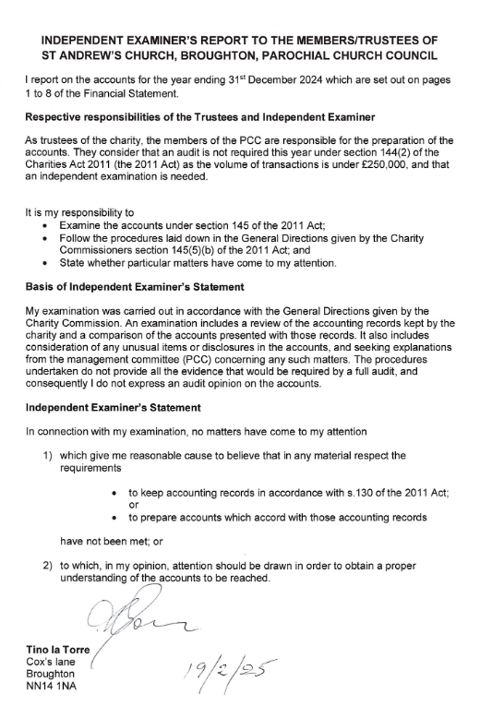

**Kettering Deanery Synod Report for 2024**

***Our mission is to encourage and support the churches of our Deanery to build the Kingdom of God. We do this by: building relationships; sharing resources; and praying for each other.***

**What is Deanery Synod?**

Kettering Deanery is one of 12 geographical areas within the Diocese of Peterborough, containing a number of neighbouring churches.

The Synod comprises the clergy of the Deanery, along with elected lay members from each parish or benefice. The number from each is linked to a church’s electoral roll. Lay members were elected in April/May 2023 for a three-year term of office.

**Who leads and manages Deanery Synod?**

The current officers are:

Rural Dean: Revd Nicki Hobbs (St Andrew Broughton with Cransley with Mawsley)

Assistant Rura Dean: Revd Tom Houston (St Andrew’s, Kettering)

Lay Chair: Peter Jackson

Secretary: Steve Atkins (resigned February 2025)

Treasurer: Alan Ridley

These officers are joined by Hazel Goodman and Lyn Ridley to form the Deanery Standing and Pastoral Committee. This group met three times during the year.

**What happens at Deanery Synod meetings?**

Meetings naturally open with Prayer and Worship. They also briefly consider recurring business items such as: reports from Diocesan and General Synod; Finance, including Parish Share; local pastoral matters.

Each meeting also has a primary focus.

Our meetings in 2024:

**February** – discussion in groups about the role of Deanery synod, why people volunteered to be involved, and hopes for future synod meetings.

**June** – visit from Bishop Debbie who spoke about her vision for the diocese and answered questions from the floor.

**October** – discussion on finances and fundraising. Alan Ridley was appointed as Deanery Treasurer. The synod voted to create a Kettering Deanery facebook group for advertising services and events, and sharing good news stories.

We also welcomed Charlie Nobbs, the Diocesan Director of Mission, to the deanery during his prayer walk round the diocesan boundary as part of Thy Kingdom Come.

**Am I able to get involved if not an elected member?**

Yes!

Speak to one or more of your church’s Deanery Synod representatives about Synod activities.

Many meetings are open to all, so why not ask what topics are planned for 2025 and consider coming along.

Sunday school

Sunday school runs twice a month and is continuing to grow in numbers which is very positive. We have an average of 15 –20 children regularly attending. We aim to give a variety of activities to suit the age range between 2-11 years. Most weeks there is art and craft, puzzles, drawing, discussion and fun based on a bible reading.

It has become part of the Sunday school session to write a collective prayer with contributions from everyone which is then read to the congregation at the end of the service.

The moving of the tables and chairs to the chancel is always a challenge and adds time to the setting up and packing away. We are looking forward to the re-ordering of the church which will mean there will be storage for furniture near at hand.

In addition to Sunday school we ran a Christmas Pizza Praise and an Easter craft afternoon, both were well attended and received positive feedback.

Charlotte and Natalie